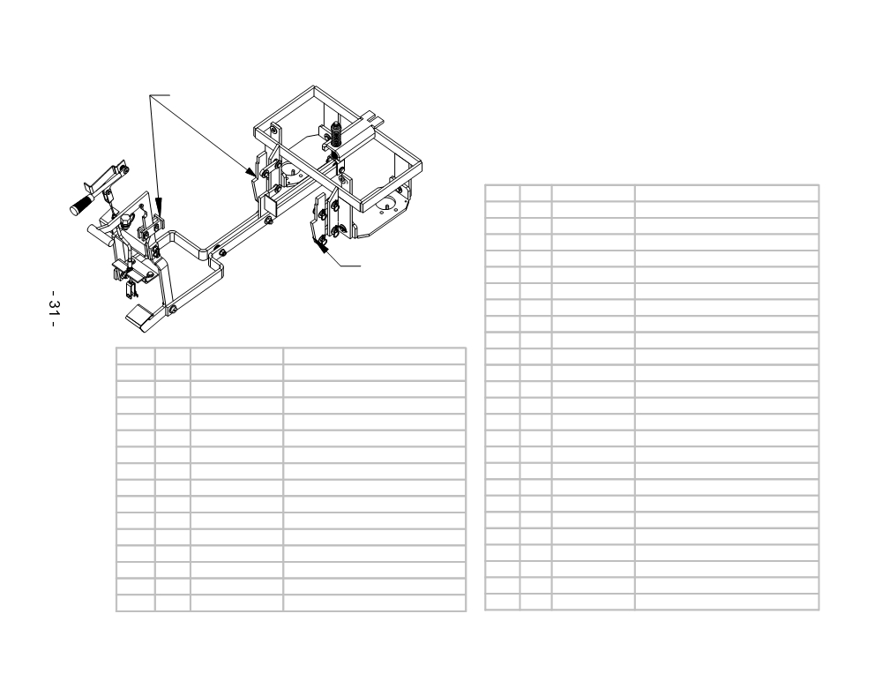

BRUSH LIFT, MOTOR MOUNT,
PART OF
THE FRAME AND SQUEEGEE LIFT
ASSEMBLED VIEW AND PARTS LIST

ITEM | SKU | Description | QTY
1 | E11054 | 3/8-16X2.50#5 BOLT HH | 1
2 | E10514 | MOTOR FRAME | 1
3 | E81080 | Bolt 3/8-16x3/4 | 2
4 | E11716 | 3/8-16x1.5 BOLT - HH | 2
5 | E11718 | #1 HAIRPIN COTTER | 2
6 | E12106 | MOTOR MOUNT, L.H. | 2
7 | E12107 | MOTOR MOUNT - R.H. | 2
8 | E11725 | 5/16x1-1/8 CLEVIS PIN | 2
9 | E11559 | LONG BUSHING | 16
10 | E11566 | LIFT HANDLE SPRING | 1
11 | E11560 | .501x.628 BUSHING | 15
12 | E81063 | Nut, 5/16" - 18, Nylon Lock | 1
13 | E12407 | 1/2 SAE FLAT WASHER GR8 PKG | 50
14 | E11179 | 1/2X1.25 CLEVIS PIN | 12
15 | E11719 | Hairpin Cotter, | 12

ITEM QTY. PART NO.
1 1 AS26/32216
2 1 AS261122
3 2 AS26/32210
4 2 AS26/32331
5 2 AS26/32333
6 2 AS26/321123
7 2 AS26/321124

PART OF
THE FRAME

DESCRIPTION
Bolt
Motor Frame
Bolt
Bolt
Hair Pin Cotter
Motor Mount, Left
Motor Mount, Right

ITEM | SKU | Description | QTY
16 | E11080 | SHOULDER SCREW | 3
17 | E11558 | LIFT CABLE | 1
18 | E11136 | 3/8 SAE FLAT WASHER | 11
19 | NLA | BRUSH LIFT ARM, LH | 1
20 | NLA | BRUSH LIFT ARM -RH | 1
21 | AS26/32654 | #N/A | 2
22 | AS26/32283 | #N/A | 7
23 | AS26/321139 | #N/A | 1
24 | E11052 | 3/8-16X1.75#5 BOLT HH | 1
25 | E11231 | BRUSH SPRING | 1
26 | E11104 | CENTERING WASHER | 2
27 | E12410 | 1/2" LOCK NUT | 1
28 | E12110 | BRUSH LIFT - PEDAL | 1
29 | E12105 | LINKAGE BAR | 4
30 | E12111 | BRUSH LIFT - BRACE | 1
31 | E12104 | BRUSH LIFT HANDLE | 1
32 | E11079 | SHOULDER SCREW | 1
33 | AS26/32986 | #N/A | 1
34 | E10778 | LEVER HAND GRIP | 1
35 | E12103 | LIFT CABLE BRACKET | 1
36 | E11891 | SQUEEGEE LIFT ARM | 1
37 | E11737 | YOKE BUSHING | 1
38 | E10010 | SHOULDER SCREW | 2
39 | E11146 | ELASTIC LOCKNUT | 7
40 | E11080 | SHOULDER SCREW | 2

ITEM QTY. PART NO.
16 3 AS26/32225
17 1 AS26/32602
18 11 AS26/32282
19 1 AS261115
20 1 AS261116
21 2 AS26/32654
22 7 AS26/32283
23 1 AS26/321139
24 1 AS26/32214
25 1 AS26721
26 2 AS26/321221
27 1 AS26/32240
28 1 AS26/321127
29 4 AS26/321120
30 1 AS26/321128
31 1 AS26/321118
32 1 AS26/32224

DESCRIPTION
Shoulder Bolt
Squeegee Lift Cable
Washer
Brush Lift Arm - Left side Brush Lift Arm - Right side Flange Bushing
Washer
Yoke Weldment for Brush Lift
Bolt
Brush Pressure Spring Cup washer
Nyloc Nut
Brush Lift Handle - Pedal Linkage Bar
Brush Lift Handle - Brace Brush Lift Handle Weldment Shoulder Bolt

8 2 AS26/32341 Clevis pin 33 1 AS26/32986 Non slip tape

9 16 AS26/32650 Flange Bushing 34 1 AS26/32992 Rubber Grip for Squeegee Lift

10 1 AS26/32722 Spring, compression 35 1 AS26/321117 Lift cable bracket

11 15 AS2632651 Sleeve Bushing 36 1 AS26/321135 Squeegee Lift Handle

12 1 AS26/32245 Nyloc Nut 37 1 AS26/32832 Brush lift yoke bushing

13 50 AS26/32278 Washer 38 2 AS26/32222 Shoulder Bolt

14 12 AS26/32248 Clevis pin 39 7 AS26/32244 Nyloc Nut

15 12 AS26/32334 Hair Pin Cotter 40 2 AS26/32225 Shoulder Bolt

